Laporan Praktikum 5

Nama : Fakhrul Anam

Kelas : 5A

NIM : 18090113

1. Source code

MatakuliahValidation.php 🡪 application/controllers/

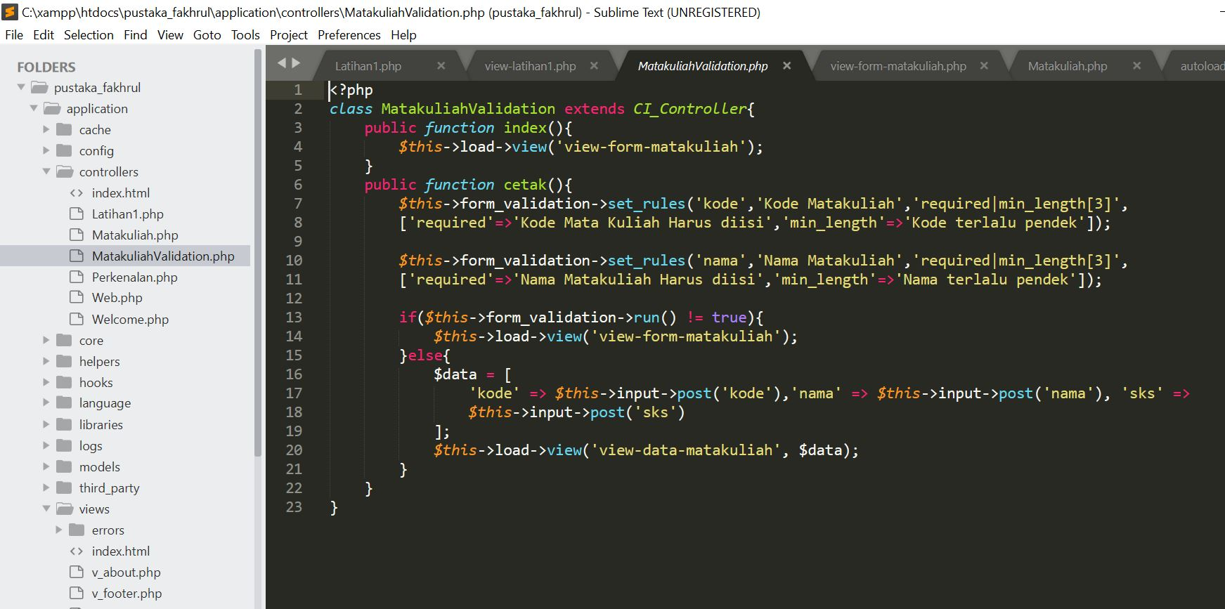

autoload.php 🡪 application/config/

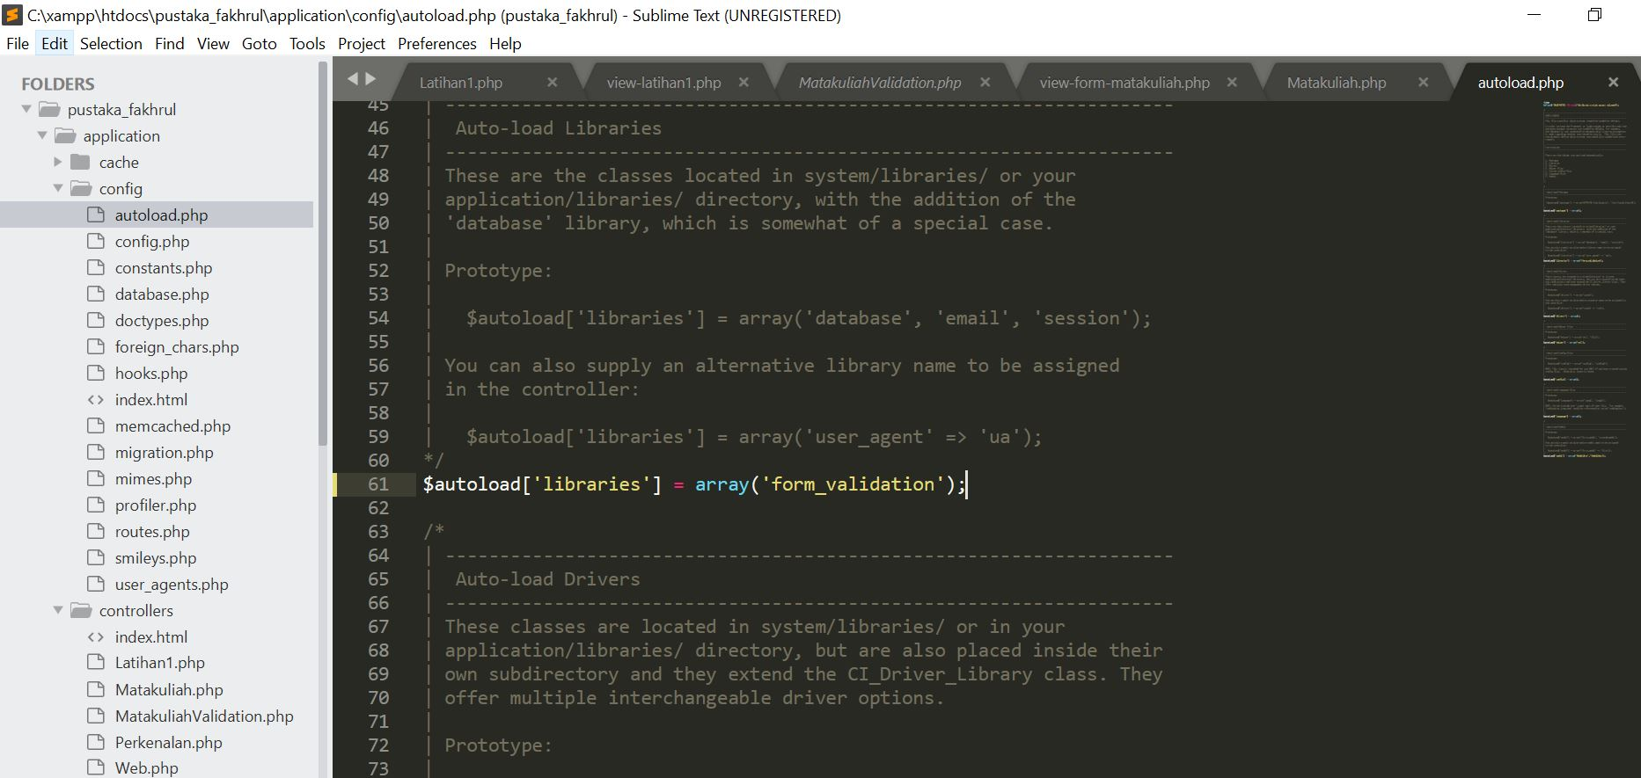

view-form-matakuliah.php 🡪 application/views/

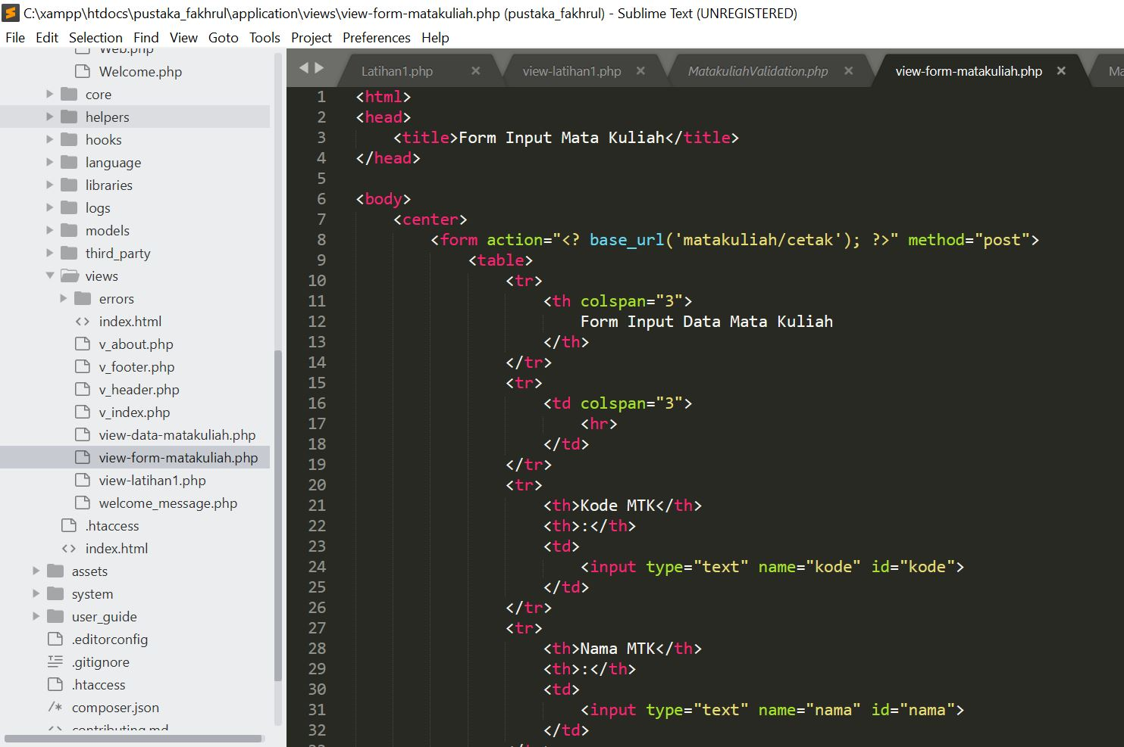

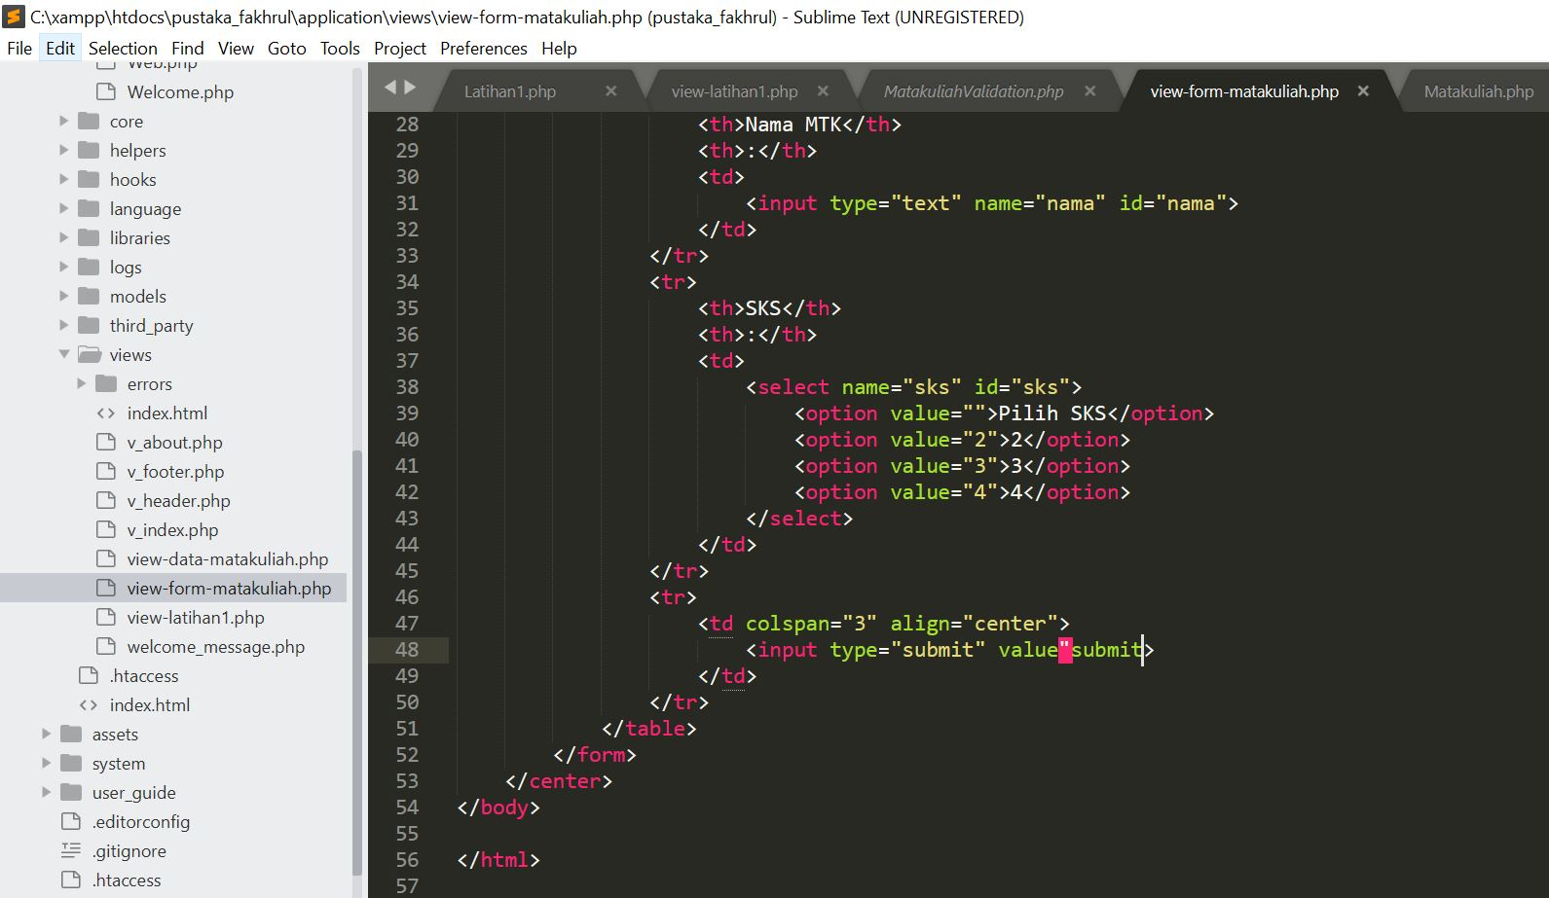

1. Capture Output Program

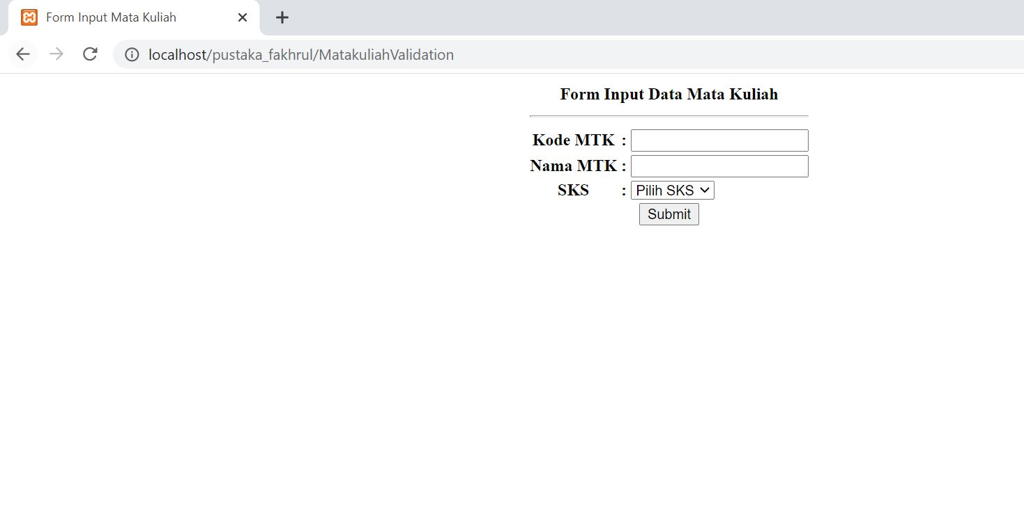

3. URL

<http://localhost/pustaka_fakhrul/MatakuliahValidation>